Chapter 5, Problem 33

Refer to the op amp circuit in Fig. 5.71. Calculate i_{x} and the power absorbed by the 3-kΩ resistor.
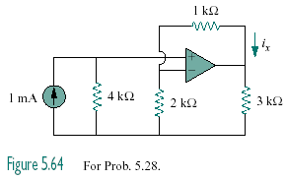

Figure 5.71
For Prob. 5.33.

